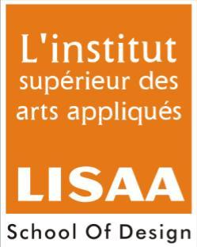
ALL INDIA LISAA CAT EXAMINATION 2013-2014
Name of Students:
Note: All questions have to be attempted
Total Marks: 75 Time: 2Hrs
- Answer the following:- 10Marks

- Zoozoo is an animated character of which mobile company?
- Idea
- Vodafone
- Airtel

- Who represented India at miss world 2012 pageant held in China?
- Purva Rana
- Vanya Mishra
- Prachi Mishra

- Visual arts can be produced with:
- Words
- Musical Sounds
- Formal elements such as line, color, texture etc.

- Ragamala is a unique feature of:
- Ajanta paintings
- Rajput miniature
- Modern Indian painting

- Match or link the following:-
- Amitabh Bachchan Atithi Devo Bhav
- Amir Khan Be a Vegetarian
- Maneka Gandhi Donate Eyes
- Aishwarya Rai End Polio Now

- Draw any three logo symbols (existing logo) and give the brief description about them in 25-30 words. (Render with black graphite pencil) 20Marks
- Discovery Channel
- NDMC
- Camel (Art Material)
- Maruti
- Hindustan Petroleum

- Illustrate a poster concept on anyone of the following topics, with the help of color pencil or poster colors. 20Marks
- Promotion of two child family
- Say no to Drugs
- Child abuse

- Draw the chosen object (anyone) along with an adult human figure in correct proportion with relevant posture. (line drawing with graphite pencil) 15Marks
- Laptop Bag
- Wardrobe
- Kitchen counter shelves above

- 1. Name the secondary and tertiary Colors. 10Marks
2. Name colors you would use in a room facing South.

