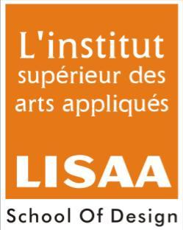
ALL INDIA LISAA CAT EXAMINATION 2013-2014
Name of Students:
Note: All questions have to be attempted
Total Marks: 75 Time: 2Hrs
- Answer the following:- 10Marks

1. Which Bollywood director is known for his political, socio political and multi starrer films? (a) Ram Gopal Varma
(b) Mahesh Bhatt
- Prakash Jha

- Which famous personality is associated with advertising industry?
- Ritu Kumar
- Praveen Bhat
- Prahlad Kakkar

- ‘The name you can bank upon’ is the slogan belonging to which bank?
- Union Bank of India
- Citi Bank
- Punjab National Bank

- Which one of these is “Synthetic Color”?
- Oil
- Acrylic
- Watercolor

- Which Indian artist became widely renowned for his oil paintings based on Indian mythological and religious subject matter?
- Biren De
- Nandlal Bose
- Raja Ravi Varma

- Draw any two logo symbols(existing logo) render and color if you can :
- D.T.C ( Delhi Transport Corporation) 20Marks
- Delhi Metro
- Vodafone
- Pepsi
- Mercedes

- Illustrate a poster concept on any one of the following topics with the help of color pencils or poster color. Write a brief description of the concept using 25-30 words use an A4 sheet. 20Marks

- Global Warming
- Save Electricity
- Save Water
- Population Control

- Draw the chosen object ( any one) along with a schematic sketch of an adult human figure in correct proportion with relevant posture (line drawing with graphite pencil). 15Marks
- Table near a window
- Folding chair
- Refrigerator

- Fill in the empty blocks with the name of the color. 10Marks
Black | + |  | = | Grey
Red | + | Yellow | =
 | + |  | = | Violet
Blue | + |  | = | Green
 | + |  | = | Pink

