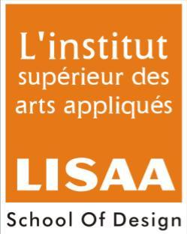
ALL INDIA LISAA CAT EXAMINATION 2013-2014
Name of Students:
Note: All questions have to be attempted
Total Marks: 75 Time: 2Hrs
- Answer the following:- 10Marks

- Which Bollywood director made a movie based on the life of Phoolan Devi?
- Sanjay Leela Bansali
- Shekhar Kapur
- Mahesh Bhatt

- Name the painter who is also a famous architect:
- Anjolie Ela Menon
- Satish Gujaral
- M.F. Hussain

- Which of the following art form is two dimensional?
- Sculpture
- Architecture
- Painting

- Who among them is not a fashion designer?
- Ritu Beri
- Raghu Rai
- Rohit Bal

- Which of the following is not a principle of design?
- Balance
- Rhythm
- Texture
- Unity

- Draw any three logo symbols (existing logo) and give a brief description about them in 25-30 words. (Render with black graphite pencil) 20Marks
- Kingfisher
- Reliance
- Star Plus
- Mother Dairy
- LIC of India

- Illustrate a poster concept on anyone of the following topics, with the help of color pencil or poster colors. 20Marks
- No Smoking
- Common Wealth Games
- Ban of female feticide

- Draw the chosen object (anyone) along with an adult human figure in correct proportion with relevant posture. (line drawing with graphite pencil) 15Marks
- Mobile Phone
- Cycle
- Ladder

- Name the following. 10Marks
- Primary colors
- Warm and cool colors

