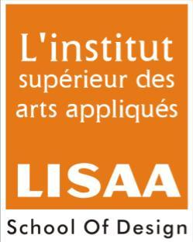
ALL INDIA LISAA CAT EXAMINATION 2013-2014
Name of Students:
Note: All questions have to be attempted
Total Marks: 75 Time: 2Hrs
- Answer the following:- 10Marks

- Match or link the following:-
- Raymond Bond with the best
- Reid and Taylor Everyone loves to perform
- Kamasutra The complete man

- Which of the following is a sculptor?
- Raja Ravi Verma
- Ramkinkar Baij
- Pandit Jas Raj

- Name the Cartoonist:
- Modigliani
- Mario Miranda
- Mondrian

- Match or link the following:
- Michelangelo The School of Athens
- Raphael Chunar Sandstone
- Natraja Chola Bronze
- Yakshi from Didarganj The Last Judgement

5. Which movie is a lose adaptation of the novel Five point someone, what not to do at IIT.
- Lagaan
- Three Idiots
- Salaam Bombay

- Draw any three logo symbols (existing logo) and give a brief description about them in 25-30 words. (Render with black graphite pencil) 20Marks
- Airtel
- Reebok
- Amul
- SBI (State Bank of India)
- Intel

III. Illustrate a poster concept on anyone of the following topics, with the help of color pencil or poster colors. 20Marks
- Save Fuel
- Population control
- Aids

- Draw the chosen object (anyone) along with an adult human figure in correct proportion with relevant posture. (line drawing with graphite pencil) 15Marks
- Stool
- Camera
- Table Lamp

- Fill in the empty blocks with the name of the color. 10Marks
 | + |  | = | Pink
Black | + |  | = | Brown
Red | + |  | = | Violet
Blue | + | yellow | =
 | + | white | =

