ENTRANCE EXAM 2008

NAME OF STUDENT: | _______________________________________________________
CONTACT ADDRESS: | _______________________________________________________
 | _______________________________________________________
COURSE APPLIED FOR: | _______________________________________________________
CONTACT NO.: | _______________________________________________________
E-MAIL ID: | _______________________________________________________

ENTRANCE TEST

Attempt all Questions

MM: 100
Time: 2 Hrs.

NAME: …………………………………… DATE: ……………………………………

COURSE APPLIED FOR: ……………………. SIGNATURE OF INVIGILATURE……………

PART-A CREATIVE ABILITY
PART-B GENERAL APTITUDE
- Analytical Ability
- Communication Ability

PART A

Q1. In the boxes given below make an illustration (with pencil only)
- which truly explains the word written under each box.
- Select any two of the boxes.
- Use of colour will result in cancellation.

CYCLE RIKSHAW

TRAFFIC JAM

CRUELTY

Q2. Design a Tee shirt/ curtain inspired from one of the following:

- Waterfall
- Clouds
- Forest

PART-B

1. Brother is to Sister as Niece is to:
- Mother
- Uncle
- Daughter
- Aunt
- Nephew
2. Skin : man ::---------------------:----------------------
- hide: animal
- jump start
- peel: potato
- eat: food
- wool : cloth1
3. Choose the word opposite in meaning to the given word:.

SCARCITY
- Plenty
- Familiarity
- Domesticity
- Promiscuity

4. Which of the following is least like the others?
- cube
- sphere
- pyramid
- circle
5. Which one of the five animals listed is least like the other four?
- Pig
- Horse
- Cow
- Snake
- Tiger
6. All pens are elephants. Some elephants are cats.

- Some pens are cats
- No pens are cats
- All pens are cats
- None of the above

7. What value will replace the question mark in the following equations?
8597- ? =7429-4358

- 5536
- 5526
- 5623
- 5784

8. If 15 toys cost Rs. 234, what do 35 toys cost?

RS.544

RS.542

RS.548

RS.546

9. a =b+3(4-c) If b equals 7 and c equals 4, what is the value of a?

10. Randy's chain of used car dealership sold 16,400 cars in 1998. If the chain sold 15,744 cars in 1999, by what percent did the number of cars sold decrease?
11. Thirty men take 20 days to complete a job working 9 hours a day. How many hours a day should 40 men work to complete the job?
- 8 hrs
- 7 1/2 hrs
- 7 hrs
- 9 hrs
12. On sports day, if 30 children were made to stand in a column, 16 columns could be formed. If 24 children were made to stand in a column, how many columns could be formed?
13. Consider the following series:
5, 9, 16, 29, 54 ____ what comes next?

14. Which number should come next in the series?
12, 36, 108, -------
- 224
- 216
- 324
- 316

15. A man buys an article for Rs. 27.50 and sells it for Rs. 28.60. Find his gain percent.
16. Five boys were climbing a hill. J was following H. R was just ahead of G. K was between G & H. They were climbing up in a column. Who was the second?

17. If it takes five minutes to boil one egg, how long will it take to boil four eggs?
18. Find the picture that follows logically from the diagrams to the right.
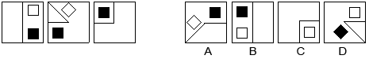
- A
- B
- C
- D

19. Which of the following diagrams is the odd one out?

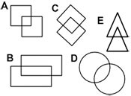

20. Which city is called the pink city of India

- Bangalore
- Vishakapattam
- Chennai
- Jaipur
- Hyderabad

PGFRM
ENTRANCE TEST

Attempt all Questions

NAME: …………………………………… DATE: ………………………..

SIGNATURE OF INVIGILATURE……………
MM: 100
Time: 2 Hrs.

Q1. What is the Full name of our previous President A.P.J. Abdul Kalam?

- Abdul Pakir Januddin Abdul Kalam
- Abdul Pakhir Jane-u-din Abdul Kalam
- Avul Pakhir Jainallabudin Abdul Kalam
- Akbar Pakir Jaruaslam Abdul Kalam
Q2. Find the answer that best completes the analogy
people : democracy :: wealthy :
A. oligarchy
B. oligopoly
C. plutocracy
D. timocracy
E. autocracy
Q3. The tip of a triangle is called the:
A. Apex
B. Top
C. Center
D. Txter
E. Trix

Q4. First day of 1999 was a Sunday. What day was the last day?
A. Monday
B. Sunday
C. Tuesday
D. Thursday
Q5. Find the answer that best completes the analogy
cherry : strawberry :: potato :
A. radish
B. lettuce
C. apple
D. banana
E. pineapple

Q6. What is the missing letter?
E | C | O
B | A | B
G | B | N
D | B | ?

Q7. Which two words are closest in meaning?
Composite, synthetic, shabby, different, pseudo, symbolic
Q8. Which number should come next in this series?
6, 24, 60,120, 210 ?
A. 336
B. 366
C. 330
D. 660
Q9. Which number should come next in this series?
8,24,12,36,18,54 ?
A. 4
B. 27
C. 31
D. 34

Q10. Which of the following is larger than 3/5?
(1) ½ (2) 39/50 (3) 7/25 (4) 3/10 (5) 59/100
Q11. A radio when sold at a certain price gives a gain of 20%. What will be the gain percent, if sold for thrice the price?
- 260%
B) 150%
C) 100%
D) 50%
E) None of these

Q12: If you look at a clock and the time is 3:15. What is the angle between the hour and the minute hands?
Answer is not 0
A) 8.5 degrees
B) 7.5 degrees
C) 79.5 degrees
D) 7.0 degrees

Q13. A zookeeper counted the heads of the animals in a zoo and found it to be 80. When he counted the legs of the animals he found it to be 260. If the zoo had either pigeons or horses, how many horses were there in the zoo?

Q14. Rohit was 4 times as old as his son 8 years ago. After 8 years, Rohit will be twice as old as his son. What are their present ages?
1. Son 16 years, Rohit 40 years
2. Son 18years, Rohit 40 years
3. Son 16 years, Rohit30years
4. Son 16 years, Rohit 43years
Q15. Vivek travelled 1200km by air which formed 2/5 of his trip.One third of the whole trip , he travelled by car and the rest of the journey he performed by train. The distance travelled by tain was???
- 700 km
- 800 km
- 750 km
- 850 km

Q16. Which diagram results from folding the diagram on the left?
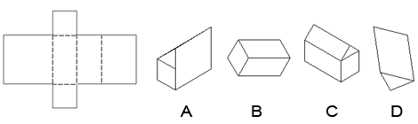

Q17. Which of the cubes is the same as the unfolded cube below?
A | B | C | D
Q 18. Pick the piece that's missing from the diagram below
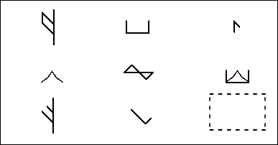
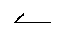 | 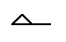 | 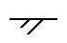
A | B | C | D

Q19.Which of the following figures is the odd one out?
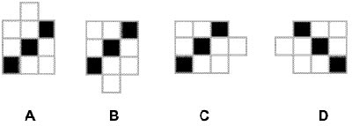

Q20. How many four sided shapes does this diagram have?
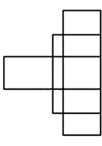
A. 5-10
B. 11-15
C. 16-20
D. 21-25
E. 26-30

